CATHOLIC UNIVERSITY: Dominican University of California

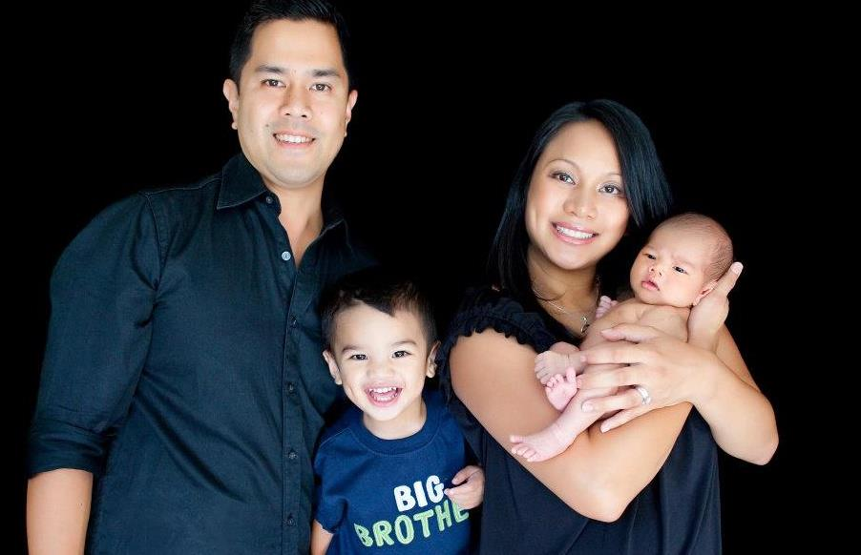
My name is Jennifer Rivera and I went to Dominican University of California, formally known as Dominican College, in San Rafael. The University is about 15 miles north of San Francisco. The Dominican Sisters of San Rafael founded the University in 1890, and it is one of the oldest universities in California. What I found interesting about this university is that it is one of the first Catholic colleges In California to grant a bachelor’s degree to women. During the early 1900’s it was a college for women, until 1971 where it became a coeducational university.
Dominican University has four schools with the following departments, School of Arts, Humanities and Social Sciences, School of Business, School of Education and Counseling Psychology and School of Health and Natural Sciences. This campus is situated in a residential neighborhood with less than 2000 students. I majored in Nursing and graduated in 2004. The beauty about this campus is that it is very small and not overwhelming with thousands of students. Prior to transferring to Dominican, I went to Cal State Long Beach where there were about 20,000 students and overwhelming. Dominican University I felt like I was in high school again. I knew almost every student in the school. My largest class I attended was approximately 30 students and the smallest class size I attended was about 3 students. Although this University has about 2000 students, I was able to stay focus with my studies and was able to meet with my professors easily. My professors knew me by my first name and not just a number. I choose this University because it very small, I can stay focus and I’ve always wanted to go to a Catholic school. Attending a Catholic college I was able to take religious studies, although this was a requirement, it allowed me to stay in touch with my Catholic faith. These classes allowed and helped me to continue to learn about my catholic faith and myself.
My fondest memory at Dominican University is when my classmates and I have down time we love to explore the campus. The campus was very lush, with lots of trees and surrounded by beautiful homes. Often times we love to do group study, because the campus was very serene. This Catholic University provided me the education I needed for my profession as well as my religious needs. This University was very small, but I was able to provide a campus life and to stay focused with school.

