100th Day Project

Dear First Grade Parents,
We are approaching the 100th day of school on February 6, 2020! To celebrate, with the help of a parent, students will complete a project at home to bring to school on the 100th day. Please see the steps below to complete the 100th Day of School Project:
Step 1: Find a clear, plastic water bottle (can be any size!). Peel the label off the side.
Step 2: Fill the water bottle with 100 of the same items (ex. 100 buttons, 100 popcorn kernels, 100 pennies, 100 Legos (make sure the lid is on top of the bottle so the items don’t fall out!).
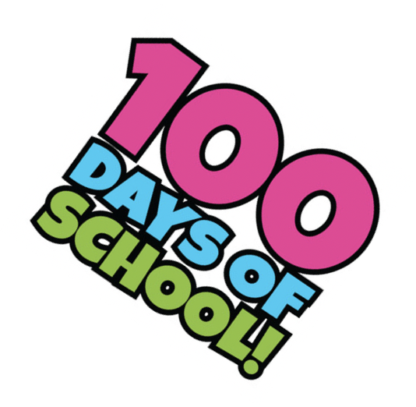
Step 3: Bring the bottle filled with 100 items to school on Thursday, February 6th. Write your child’s number on the lid. Make sure your child is ready to present their bottle to the class!
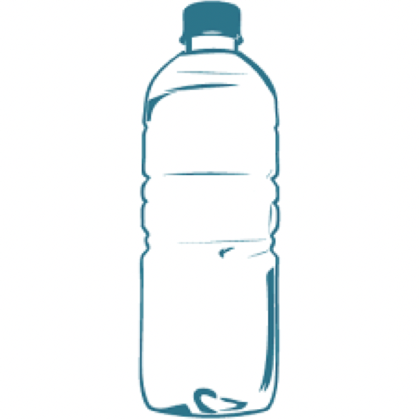
Project Due Date: February 6, 2020
5 points = Work Habits
5 points = Math

