5th Grade State Report
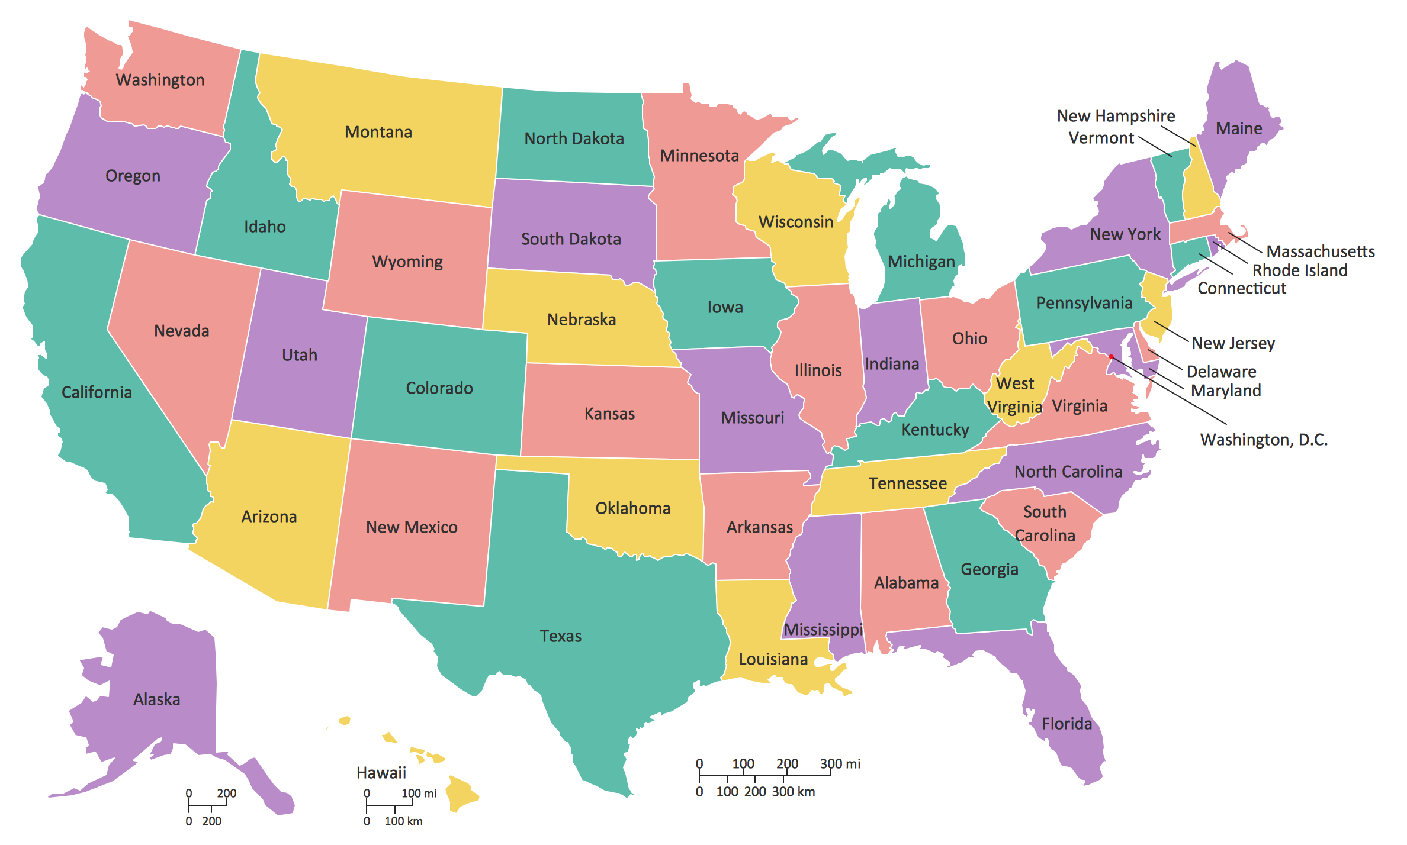

In the next few weeks we will be working on our state report. We will have some time during the weeks to work on the research for the reports in the Learning Lab. However, most of the work will need to be done at home.

The report will consist of a Flour/ Salt map of your chosen state, a poster showing the important features of your state, a typed report about your chosen state, and a presentation on your state.

FLOUR/ SALT MAP
- This part of the project will consist of a map of your chosen state made out of flour, salt, and water
  - Mixture: 2 cups of flour, 1 cup of salt, and 3/4 cup of water
  - Mix water slowly, if mixture is too “runny” add more flour
- Put the dough on a piece of cardboard (at least shoe box size to at most 13 X 19”) and start to create map
- The map will have to show the state’s landmarks (state capital, important cities, rivers, mountains, etc.).
- Once the map is dry, students will have to paint the map (to show rivers, cites, etc.)
- Cities can be distinguished through dots, toothpicks, flags, etc. whichever way you would like to label them is ok, just make sure they are labeled.

POSTER
- Will include what state it is, state nickname, state flag, state capital, what state is famous for, state tree, state bird, state flower, bordering states and interesting facts about state.
- Students will be given ONE poster outline. If it is lost, then student will be responsible for re-creating the poster.

TYPED REPORT
- Will include Cover Page, History, Geography, Agriculture/ Industry, Famous People, Tourist Attractions (at least 2), Interesting or Unusual Facts, which Mary is used in the states Catholic Churches, and Bibliography of sources used (at least three sources need to be used).
- Report much be typed in either 12 or 14 font, Calibri or Times New Roman Font.
  - Please talk to me if typing the report is a problem.
  - An outline is attached

PRESENTATION
- Students will have to prepare a 10-15 min presentation about their state

Rubrics are on the following pages

***DUE DATE: The flour/ salt map, poster, and typed report will be due Friday, January 24. Presentations will start the week after on Monday, January 27^{h}.

EXTRA CREDIT: Students who also create a poster about their state’s Mary will we receive 5 extra credit points

If you have any questions on this project, please email me at jmahar@stanthonygardena.org
Rubric for Flour/ Salt Map
 | 1 | 3 | 5 | Total
Neatness | Map is not neat, very messy and not thought out | Map is partially neat and though out | Map is very neat, tidy, and well thought out
Creativity | Map lacks creativity and is not colorful | Map has some color and some creativity | Map is very colorful and layout is creative
Accuracy | Map is not accurate, cannot determine state and cannot see the landmarks | Map is somewhat accurate, some landmarks are questionable | Map is very accurate, able to determine state easily and able to see landmarks easily

TOTAL: / 15

Rubric for Poster
 | 1 | 3 | 5 | Total
Neatness | Poster in not neat, very messy, and not thought out. | Poster is partially neat | Poster is very neat, and well thought out
Creativity | Poster lacks creativity and color | Poster is somewhat colorful | Poster is very colorful
Completeness | Poster is incomplete | Poster is somewhat complete | Poster is fully complete

TOTAL: / 15

Rubric for Presentation
 | 1 | 3 | 5 | Total
Content | Presentation had no content | Presentation had good content | Presentation had great content
Preparedness | Student was not prepared for presentation | Student was somewhat prepared for presentation | Student was very prepared for presentation
Delivery | Presentation was not clear, understandable and in allotted time | Presentation was somewhat clear, understandable, and within allotted time | Presentation was very clear, understandable, and within allotted time

TOTAL: / 15
Rubric for Typed Report
 | 1 | 3 | 5 | Total
Cover Page | No cover page | Incomplete cover page | Includes state name, student name, teacher name, and image of the state
History | No mention of state’s history | Include at least 3 sentences about history | Includes at least one paragraph (5 sentences) about the history of the state.
Geography  (Location, landforms, cities, and weather) | No mention of Geography | Includes at least 3 sentences about Geography | Includes one paragraph (5 sentences) about Geography
Industry/ Agriculture  (Types of jobs, food, crops) | No mention of Geography | Includes at least 3 sentences about Industry/ Agriculture | Includes one paragraph (5 sentences) about Industry/ Agriculture
Famous People  (2 minimum) | No mention of the famous people | Only mentions the famous people (no short biography) | Includes at least one paragraph (5 sentences) about the famous people and a short biography on them.
Tourist Attractions  (2 minimum) | No mention of the tourist attractions | Includes at least 3 sentences about tourist attractions | Includes at least one paragraph (5 sentences) about the tourist attractions
Interesting Facts  (2 minimum) | No mention of the interesting facts | Includes at least 3 sentences about interesting facts | Includes at least one paragraph (5 sentences) about the interesting facts the state has
Mary in the State | No mention of the state’s Mary | Includes at least 3 sentences about the state’s Mary | Includes one paragraph (5 sentences) about the state’s Mary
Bibliography  (On separate page, at least 3 sources) | No sources listed | List only 1 sources in finding information | List at least 3 sources used in finding information

TOTAL: / 45
State Report Outline
- Cover Page (on one page by itself)
  - State name
  - Your name
  - Teacher name
  - Image of the state
- Introduction/ History
  - Tell why you chose this state
  - Date of statehood (when did it become a state)
  - Order in which your state became a state (what number state is it)
  - Important dates/ events in your state’s history
  - Any other important facts you would like to add (people that live there, early exploration, etc.)
- Geography/ Climate
  - Land information (landforms)
    - Mountains
    - Area (north, south, east, west…)
    - National parks
    - Rivers or lakes
  - Size of your state
  - Important cities (including the capital)
  - Any other important information
  - Climate (weather)
- Industry and Agriculture (what does your state do to make money)
  - Farming
  - Manufacturing/ processing
  - Mining
  - Fishing
- Famous People (at least 2)
  - Who is from your state that is famous
  - Short biography on these people
- Tourist Attractions (at least 2)
  - Tell about at least 2 places that someone cloud visit if they come to your state.
    - What can they do there?
    - Any other information you want to add
- Interesting Facts (at least 2)
  - At least one paragraph about the interesting facts about the state
  - These can be funny or serious facts
- Mary of the State
  - Who is the Mary of your state?
  - Includes one paragraph about the state’s Mary, churches named after her, and how she got her name.
- Bibliography (at least 3)
  - List at least 3 sources (where did you get your information)
    - Books, online, etc.

