100th Day of School
Collage Project

Dear First Grade Families,

We have a very exciting day coming up soon! On February 5th, 2021, Friday, we will be celebrating the 100th day of school. We will be celebrating with many “100” activities throughout the day.

For our first grade project this month, your child will be creating a “100” collage to share with the class. This is an opportunity for families to work together and be as creative as they can be by making a collage to display 100 items.

Directions:
- Brainstorm ideas with your child. Google and Pinterest have lots of ideas, or see the attached examples.
- Gather 100 items to create your design on the collage. You may use 22x28in poster or foam board as a base.
- When creating your collage, please securely fasten all objects. I recommend using lightweight items and hot glue.
- Have fun and be creative in your design.
- Please have your child post a clear picture of his/her work on Seesaw by Feb. 4th, 2021, Thursday. They will be presenting it to the class on the week of Feb 8th-12th. The project must be dropped off at school on our next Drive-by mass on March 5th, 2021.

I am excited and can’t wait to see all their awesome designs! Enjoy!

Warmly,
Ms. Martinez
Examples if 100th day Collages
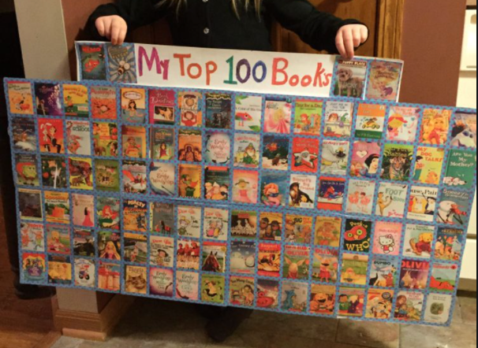

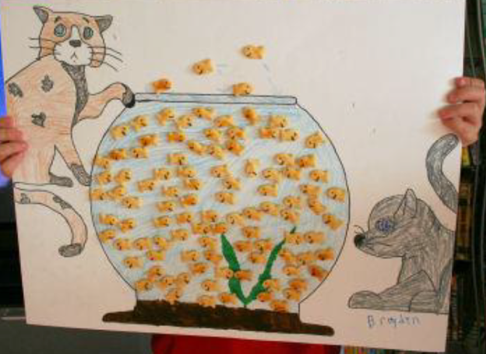
More ideas for your own collage

- Stickers
- Pompoms
- Googly eyes
- Cereals
- Pasta shapes
- Buttons
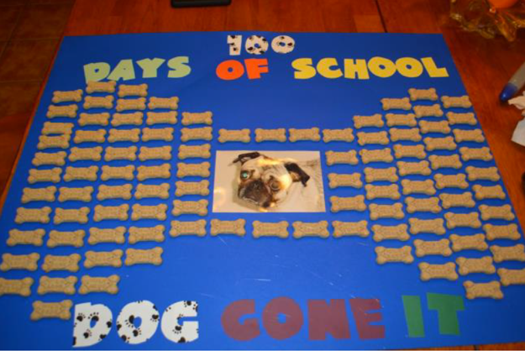
- Paper clips
- Ribbons or bows
- Feathers
- Buttons, sequins, beads
- rhinestones
- Shells
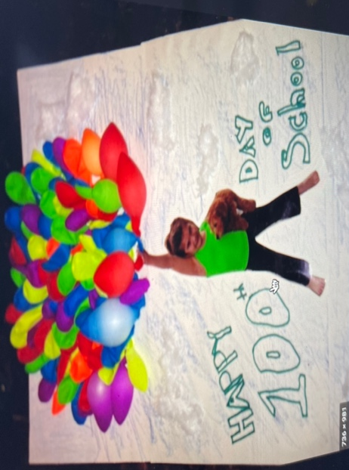
- Dried flowers / leaves
- Craft sticks
- Legos
- Erasers
- Puzzle pieces
- Seeds
- Paint samples

You get the idea!

