My Baptism Folder

Dear First Grade Parents/ Guardians,

For the upcoming weeks, we will be learning and talking about baptism.

Baptism is one of the Seven Sacraments. It is a special celebration when one is welcomed officially into the Catholic Church with holy water.

Take some time this week to discuss baptism with your child. If they have been baptized, tell stories, look at the pictures, and remember their baptism together. Remind them who their godparents are, what they wore, and look at their baptism candle. If they have not been baptized, share the story when they were born. Look at pictures and share any special gifts, clothing, memories, etc. We will be discussing these special memories in class.

Together with your child, fill out the attached sheets describing how their name was chosen and other information. Return this project to class by May 14, 2021. Students can also provide pictures of their baptism or real objects from their baptism and design their baptism folder. I will be grading their creativity, information sheets, & work habits.
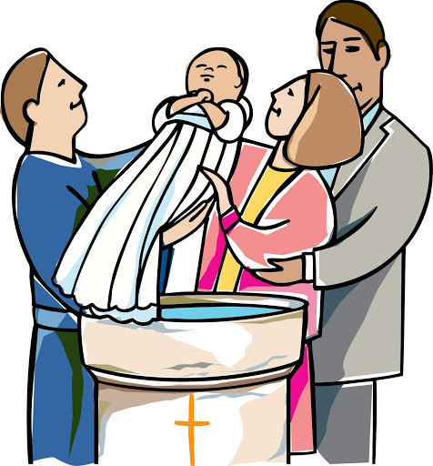

Sincerely.
Ms. Martinez ️

