LET YOUR FINGERS DO THE SHOPPING AT THE OCEAN INSTITUTE GIFT SHOP!
Your child can take home a memento from the Ocean Institute. Use this form to order in advance. Place completed order form and the total purchase amount (cash or check made payable to Ocean Institute Gift Shop) in an envelope with your child’s name on it and give it to your child’s teacher. SUBSTITUTIONS: If an item is out of stock, substitutions will be made automatically.
*If you would prefer we not make any substitutions, please check here: NO Substitutions
QUESTIONS? (949) 496-2274, EXT 510
Child’s Name: ________________________________ Teacher’s Name: ___________________________________
School Name: ___________________________________________________________________________________
ITEM NAME | PRICE | QTY | TOTAL
PILGRIM MAGNET | $5.39
SPIRIT OF DANA POINT MAGNET | $5.39
OI TRAVEL MUG | $12.93
LARGE SHARK TOOTH FOSSIL | $10.72
OI SHARK TOTE | $9.16
OI BALL CAP | $21.50
WOOD FOIL PENCIL (COLORS MAY VARY) | $0.81
POLISHED ROCKS IN VELVET BAG (COLORS MAY VARY) | $5.39
AUTHENTIC REPLICA, TREASURE COIN- GOLD | $2.13
AUTHENTIC REPLICA, TREAUSRE COIN- SILVER | $2.13
MINI RUBBER SEALIFE – 5 assorted figures | $4.04
OI STICKER | $2.69
OI SEA STAR ORNAMENT | $9.16
***FOR YOUR CONVENIENCE, PRICES INCLUDE SALES TAX*** | TOTAL DUE | No. Items | $

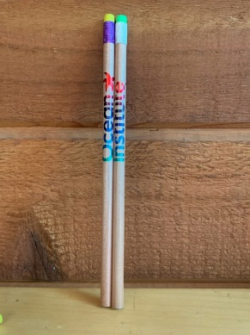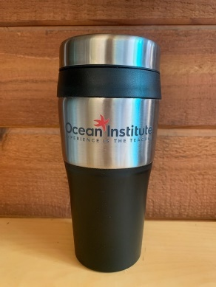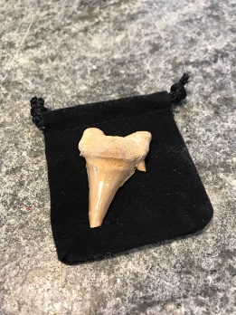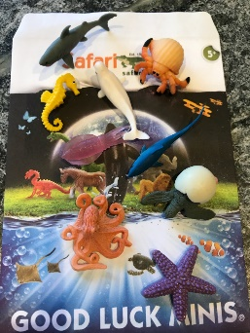
WOOD FOIL PENCIL OI SPIRIT TRAVEL MUG LARGE SHARK TOOTH RUBBER MINI

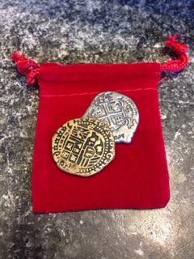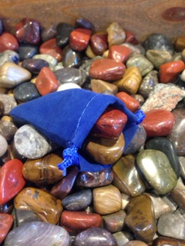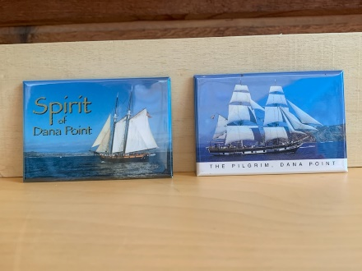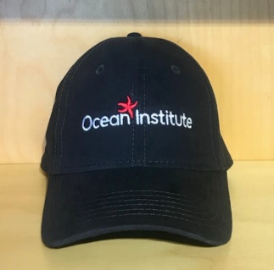
TREASURE COIN POLISHED ROCKS MAGNETS OI BALL CAP

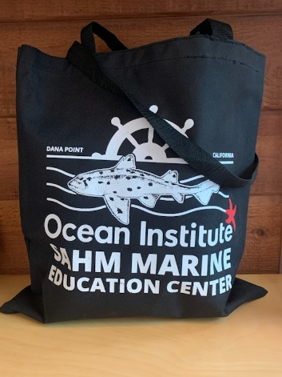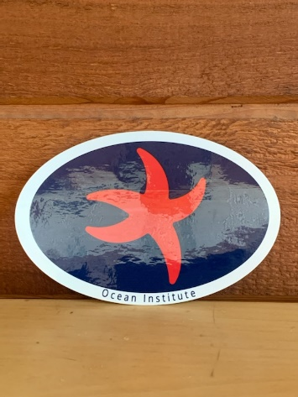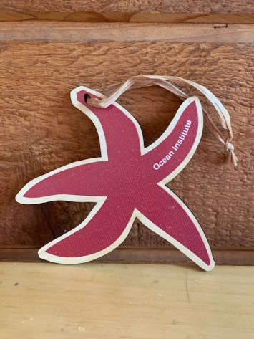
OI SHARK TOTE OI STICKER OI SEA STAR ORNAMENT

LET YOUR FINGERS DO THE SHOPPING AT THE CHAMBERS GALLERY!
**TEACHER COPY** Return completed Teacher Order form only to Ocean Institute Gift Shop before your program. Total purchase amount (cash or check made payable to Ocean Institute Gift Shop) can be mailed in or brought to the gift shop on the day of your program. SUBSTITUTIONS: If an item is out of stock, substitutions will be made automatically.
*If you would prefer we not make any substitutions, please check here: NO Substitutions
QUESTIONS? (949) 496-2274, EXT 510
kwhitechurch@oceaninstitute.org
Date of Program: _____________________ School Name: ____________________________________________________
Teacher’s Name: _________________________________________________________________________________________
Contact Number: __________________________Contact Email: ________________________________________________
ITEM NAME | PRICE | QTY | TOTAL
PILGRIM MAGNET | $5.39
SPIRIT OF DANA POINT MAGNET | $5.39
OI TRAVEL MUG | $12.93
LARGE SHARK TOOTH FOSSIL | $10.72
OI SHARK TOTE | $9.16
OI BALL CAP | $21.50
WOOD FOIL PENCIL (COLORS MAY VARY) | $0.81
POLISHED ROCKS IN VELVET BAG (COLORS MAY VARY) | $5.39
AUTHENTIC REPLICA, TREASURE COIN- GOLD | $2.13
AUTHENTIC REPLICA, TREAUSRE COIN- SILVER | $2.13
MINI RUBBER SEALIFE – 5 assorted figures | $4.04
OI STICKER | $2.69
OI SEA STAR ORNAMENT | $9.16
***FOR YOUR CONVENIENCE, PRICES INCLUDE SALES TAX*** | TOTAL DUE | No. Items | $

