Third Grade Saints in Training Saint Report Information
DUE DATE: November 1st(Monday)
Dress up: November 1st(Monday)

● What is needed in the Report:

Artistic Piece - CHOOSE 1

Poster -Hand drawn or Computer Generated
- Must include:
- Picture of the Saint
- Years they were born and died
- Where they lived
- 3 Facts about the Saint
- Why they are important now

Podcast or Video Presentation
- Where and when was the saint born
- What they are the patron saint of
- 1-3 facts about their life or interesting stories
- How and when they died
- Why they are important now

Brochure -Hand drawn or Computer Generated
- Picture of the Saint
- Year they were born and died
- Where they lived
- 3 Facts about the Saint

Craft
- Be creative!
- Find or write instructions for a craft relating to your saint
- Craft must be related to where they lived
- on a notecard or in craft instructions write:
- Year they were born and died
- Where they lived
- what they are patron saint of
- How they are remembered as a saint
With the 1 Artistic Piece, YOU MUST do this too
Powerpoint
- Include:
  - Slide 1: Picture/Name of the Saint
  - Slide 2: Date and Year born and Died
  - Slide 3: Where they lived
  - Slide 4: What are they the patron saint of?
  - Slide 5: 5 or more facts about the saint
*We will work on the powerpoints in class, but what they do not finish MUST BE DONE AT HOME BEFORE NOVEMBER 1st

o DRESS UP: Students will get points for dressing up as any saint of their choice for the November 1st Mass.
▪ Points are explained in the rubric

● EXTRA CREDIT OPPORTUNITY: students that prepare and present a 3-5 minute presentation for the class on their saint (using the Powerpoint Slides) will receive 5 points in extra credit (or credit added to score)
****Students will be able to dress up as a Saint of their choice (NO cross-dressing),

Examples
Poster (I found a lot on google and pinterest) can use online template or hand crafted

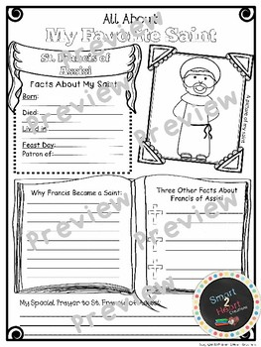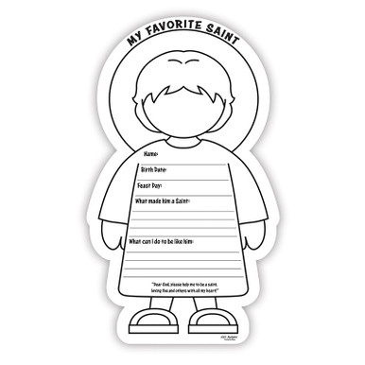

Podcast
https://shininglightdolls.com/pages/saint-stories-for-kids

Brochure
Can use template from online or hand crafted
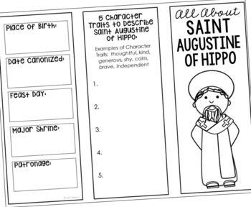
Craft (must include explanation as well)
St. Francis Bird Feeder
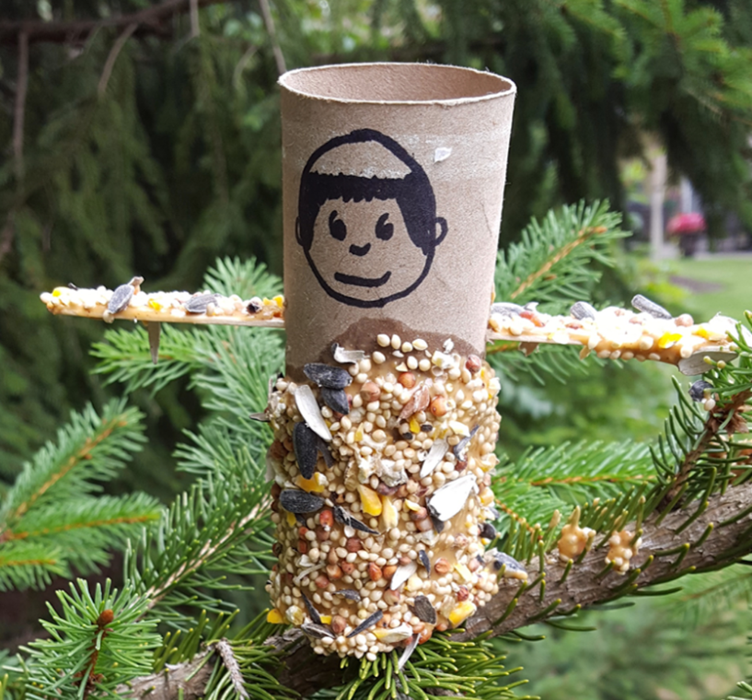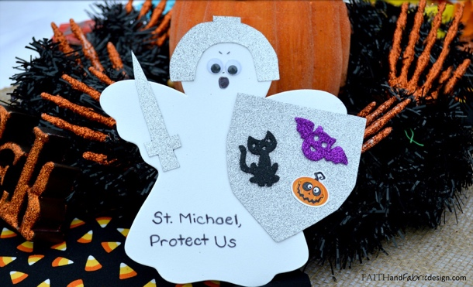

Saint dolls
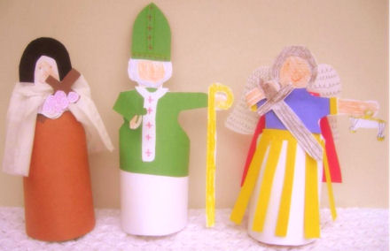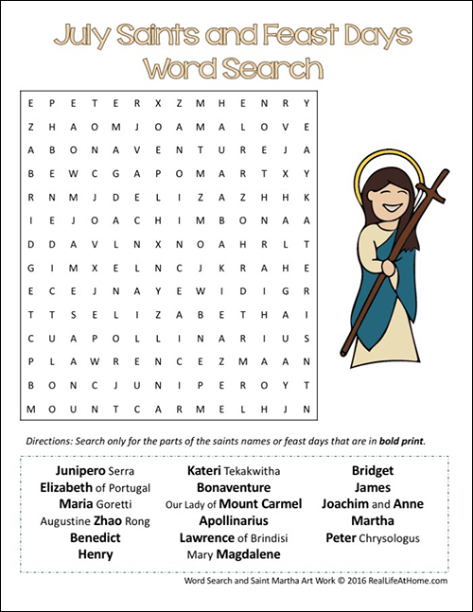

Saint Costume Rubric
