100th Day of School Collage Project

Dear First Grade Families,

We have a very exciting day coming up soon! On February 7^{h}, 2023, Tuesday, we will be celebrating the 100th day of school. We will be celebrating with many “100” activities throughout the day.

For our first-grade project this month, your child will be creating a “100” collage to share with the class. This is an opportunity for families to work together and be as creative as they can be by making a collage to display 100 items.

Directions:
- Brainstorm ideas with your child. Google and Pinterest have lots of ideas, or see the attached examples below.
- Gather 100 items to create your design on the collage. Use a 22x28in poster or foam board as a base.
- When creating your collage, please securely fasten all objects. I recommend using lightweight items and hot glue.
- With your help, have your child create their own design.
- Students will bring their projects on Monday, Feb 6th to school.

I will be grading the following:
Rubric | Points
Following instructions | 10
Presentation | 10
Creativity | 30
Total | 50

I am excited and can’t wait to see all their awesome designs!

Warmly,
Ms. Martinez

Examples 0f 100th day Collages
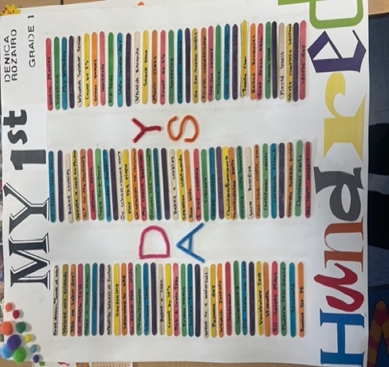
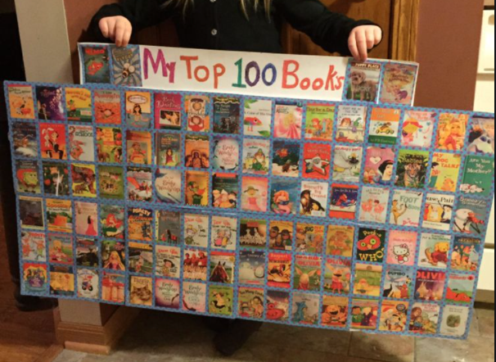

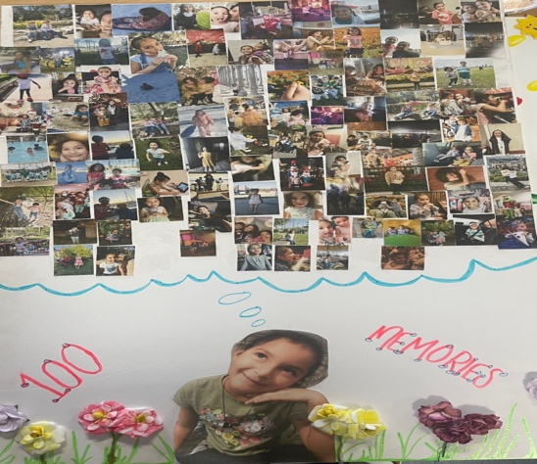
More ideas for your own collage:

- Stickers
- Pompoms
- Googly eyes
- pictures
- Pasta shapes
- Buttons
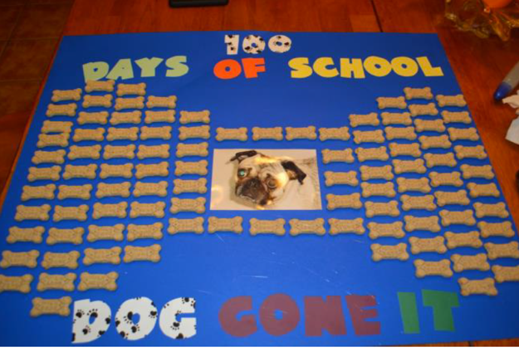
- Paper clips
- Ribbons or bows
- Feathers
- Buttons, sequins, beads
- rhinestones
- Legos
- Dried flowers / leaves
- Craft sticks
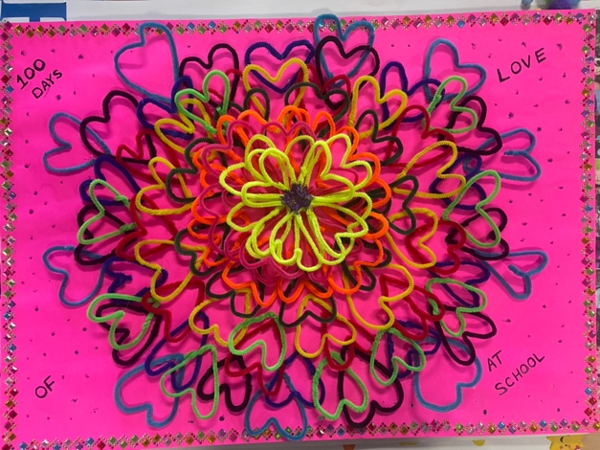
- Leaves
- Erasers
- Puzzle pieces
- Seeds
- Paint samples

You get the idea!

