Thursday, Jan 16th – Friday, Jan 17th

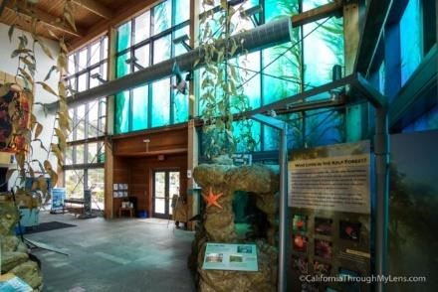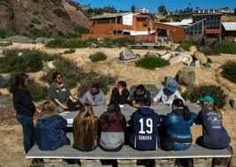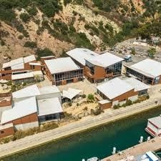

# Important Information

* Please confirm with Ms. Alejandre no later than **Monday, Dec. 9th** that your student will be participating.

* If all 29 students join, each family will need to provide \***$50** for their student in a labeled envelope, which will be collected on or before the day of the field trip. (*This amount may change depending on the final number of students participating in the program.)
* All 5th graders must arrive at school with their packed items between **1:00pm** and **1:10pm**. Please ensure your student has eaten lunch. (We will be gathering in side parking lot until the end of Lunch.)
* Busses with students & 6 adults (5 Chaperones & Ms. Alejandre) will depart at **1:30pm**.

* Chaperones will be using our Parent Connect **Band App** to provide updates, share pictures and respond to any questions. Additionally, Chaperones have shared their **contact information** should you want to reach out for any reason.

* All meals have been planned and will be provided therefore there is no need to pack food. (All Students will be given snacks.)

* Planned arrival back on campus be **11:00am**, January 17 (Friday). Please ensure planning for your student to either be picked up upon arrival **OR** to remain on campus until 3pm dismissal.

* *For students needing to remain, please consider paying for school lunch for 01/17/25 or dropping off a lunch for them that morning at school.

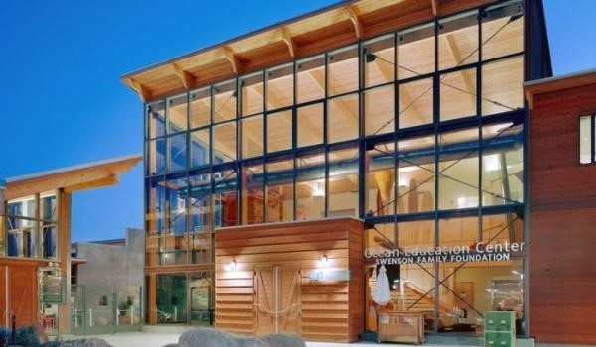

# Itinerary of Activities at Ocean Institute

|  |  |
| --- | --- |
| **Time** | **Activity Day 1** |
| 3:00 pm | School arrives |
| 3:25 pm | Meet the Captain |
| 3:30 pm | Safety Orders and put away gear |
| 3:45 pm | Shipboard directions |
| 4:00 pm | Introduction to Bell Time and Working Orders |
| 4:20-6:20pm | Rotations |
| 6:30 pm | Dinner Orders |
| 6:45 pm | Dinner |
| 7:00 PM | Head Orders |
| 8:00pm | Introduction to Dog Watch |
| 9:30pm | Introduction to Night Watch |
| 9:45pm | Night Watch/ Bedtime |
| 9:45pm-10:00pm | Goodnight Calls Home (With help from Chaperones) |
| **Time** | **Activity Day 2** |
| 6:00 am | Wake up |
| 6:20 am | Raise Colors and eat breakfast |
| 7:00 am | Clean up gear |
| 8:00 am | Morning Summation |
| 9:00 am | Good-bye! |

# Chaperones

|  |  |
| --- | --- |
| Mr. Juan Pineda (Parent of Aiden) | (310) 756-4740 |
| Ms. Laura Marquez (Parent of Emily) | (310) 415-6462 |
| Ms. Mayra Trejo (Parent of Valissa) | (310) 365-7440 |
| Ms. Evangelina Gomez (Parent of Gabriel) | (323) 346-7216 |
| Ms. Maricel Tubal (Parent of Alisa and Reina) | (424) 392-9407 |

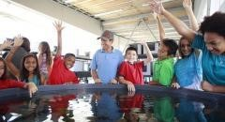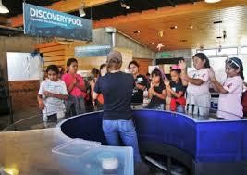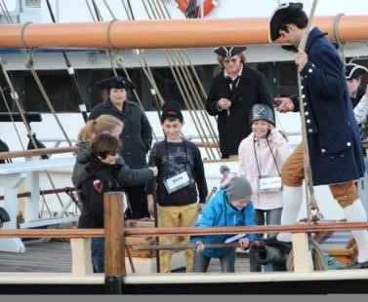

# Packing List

*Please ensure your student comes dressed comfortably for all of the

Activities for Day 1. Preferably pants, closed toed shoes and a sweatshirt.

* Backpack or Small Rolling Suitcase
* **1** Small personal bag, purse, fanny pack or backpack to hold water bottle or any other items to have with them during drive. o **1** Plastic Bag for all Sleeping Items
* **1** Gallon Sized Ziplock Bag for all Toiletries/Hygiene Items o 1 Sleeping bag (*Packed in a labeled plastic bag) o 1 Small blanket (*Packed in a labeled plastic bag) o 1 Small pillow (*Yes – you guessed it, same as above) o 1 Pair of Pajamas or Comfortable Clothes for Sleeping o 2 pairs of socks o 1 Jacket or Sweatshirt o 1 pair of sandals or slippers
* Clothing for Day 2 (Similar to what was worn Day 1)
* Toothbrush & Toothpaste o Hairbrush or Comb o Small Washcloth
* Personal Hygiene Items Needed by Your Student (e.g. deodorant, hand/body wipes, etc.) o Parent cell phone number for their Goodnight Call

***This will no doubt be one of the most memorable experiences for your Student.***

***(Maybe yours too!)***

***Thank you PARENTS!***